Business Cycle, Output Gap and Unemployment Questions
- If actual output is greater than potential output, what can be said about actual unemployment compared to the natural rate of unemployment?
- Actual unemployment is higher than the natural rate of unemployment.
- Actual unemployment is equal to the natural rate of unemployment.
- Actual unemployment is lower than the natural rate of unemployment.
- There is no relationship between actual output and unemployment.
- During a recession, actual output is below potential output. What is true about cyclical unemployment?
- Cyclical unemployment is zero.
- Cyclical unemployment is positive.
- Cyclical unemployment is negative.
- Cyclical unemployment does not exist during a recession.
- What can be said about actual output if cyclical unemployment is zero?
- Actual output is below potential output.
- Actual output is greater than potential output.
- Actual output is equal to potential output.
- Actual output is unrelated to cyclical unemployment.
- What typically happens to unemployment during an economic boom, when the actual output exceeds potential output?
- Unemployment remains at the natural rate.
- Unemployment rises above the natural rate.
- Unemployment falls below the natural rate.
- Unemployment is unaffected by changes in output.
- When cyclical unemployment is present, what can be said about actual output?
- Actual output is less than potential output.
- Actual output is greater than potential output.
- Actual output is equal to potential output.
- Actual output is unaffected by cyclical unemployment.
- In a negative output gap, what happens to cyclical unemployment?
- It decreases because the economy is growing.
- It increases because actual output is below potential output.
- It stays the same because only structural unemployment changes.
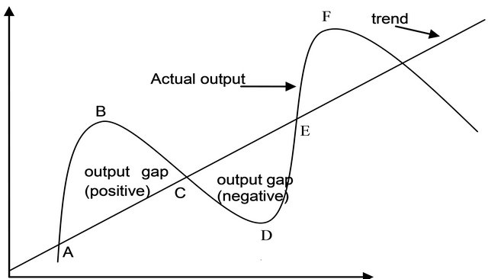
- It decreases because actual output is greater than potential output.
- Using the provided graph, when the economy is operating at potential output, which of the following is true about cyclical unemployment?
- Cyclical unemployment is positive.
- Cyclical unemployment is negative.
- Cyclical unemployment is zero.
- Cyclical unemployment fluctuates regardless of output.
- If cyclical unemployment increases, what can be said about the level of output in the economy?
- Output has likely increased above potential output.
- Output has likely decreased below potential output.
- Output is equal to potential output.
- Output is not related to cyclical unemployment.
- If the economy is producing at potential output, which of the following is true?
- Actual unemployment is higher than the natural rate of unemployment.
- Actual unemployment is lower than the natural rate of unemployment.
- Actual unemployment is equal to the natural rate of unemployment.
- Actual unemployment is not related to potential output.
- What can be said about the unemployment rate during a period when actual output is below potential output?
- The unemployment rate is equal to the natural rate of unemployment.
- The unemployment rate is higher than the natural rate of unemployment.
- The unemployment rate is lower than the natural rate of unemployment.
- The unemployment rate is unrelated to the level of output.
- If actual unemployment is lower than the natural rate of unemployment, what can be said about output?
- Actual output is greater than potential output.
- Actual output is less than potential output.
- Actual output is equal to potential output.
- Output is not related to the unemployment rate.
1 | C | 6 | B | 11 | A
2 | B | 7 | C | 12 | C
3 | C | 8 | B | 13 | C
4 | C | 9 | C | 14 | C
5 | A | 10 | B | 15 | B

- In which situation is cyclical unemployment likely to be zero?
- During a recession
- During a boom
- When actual output is equal to potential output
- When actual output is less than potential output
- When the economy is experiencing a positive output gap, what is likely true about cyclical unemployment?
- Cyclical unemployment is zero.
- Cyclical unemployment is positive.
- Cyclical unemployment is negative.
- Cyclical unemployment remains constant.
- During a recession, actual output is below potential output. What is true about actual unemployment compared to the natural rate of unemployment?
- Actual unemployment is lower than the natural rate of unemployment.
- Actual unemployment is equal to the natural rate of unemployment.
- Actual unemployment is higher than the natural rate of unemployment.
- Unemployment is not affected by the level of output.
- Which of the following scenarios best describes a positive output gap?
- Actual output is less than potential output, and unemployment is above the natural rate.
- Actual output is greater than potential output, and unemployment is below the natural rate.
- Actual output is equal to potential output, and unemployment is at the natural rate.
- The economy is in a deep recession, and output is far below potential output.

